**Bihar**

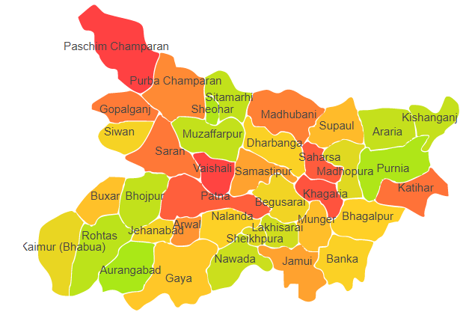

Bihar comprises of two Agro Ecological Regions (AER) namely 9 and 13.

**Agro-Eco Region 9:** AER 9 in Bihar comprises of Arwal, Aurangabad, Bhabua, Bhojpur, Buxar, Gaya, Jahanabad, Nalanda, Nawada, Patna, Rohtas and Sheikhpura districts of Northern Plain under Agro Ecological Sub Regions (AESR) 9.2.

**Agro-Eco Region 13:** AER 13 in Bihar comprises of Arariya, Banka, Begusarai, Bhagalpur, Drabhanga, Gopalganj, Jamui, Katihar, Khagaria, KishanganJ, Lakhisarai, Madhepura, Madubani, Munger, Muzaffarpur, Pachim Champaran, Purba champaran, Purnia, Saharsa, Samastipur, Saran, Sheohar, Sitamarhi, Siwan, Supaul and Vaishali districts of Eastern Plain under Agro Ecological Sub Regions (AESR) 13.1.